Paul G. Allen School Early Space History

What is today the University of Washington's Paul G. Allen School of Computer Science & Engineering was established by the University of Washington Board of Regents as the Computer Science Group – a graduate program reporting to the Dean of the Graduate School – in March 1967. Jerre Noe was hired from SRI in 1968 to lead the group (and to lead its growth into a full-fledged academic department with an undergraduate program).

As of 2019 the Allen School has 78 faculty members, but in 1970 there were 7:

Jean-Loup Baer (hired as a new UCLA graduate in 1969; retired in 2003)
David Dekker (moved to the Computer Science Group from UW’s Department of Mathematics; retired in 1981; passed away in 2004)
Hellmut Golde (moved to the Computer Science Group from UW’s Department of Electrical Engineering; retired in 1992; passed away in 2019)
Ted Kehl (moved to the Computer Science Group from UW’s Department of Physiology & Biophysics; retired in 1997; passed away in 2019)
Jerre Noe (hired away from SRI in 1968; retired in 1988; passed away in 2005)
Bob Ritchie (moved to the Computer Science Group from UW’s Department of Mathematics; departed for Xerox PARC in 1983; passed away in 2019)
Joe Traub (hired away from Bell Laboratories in 1970; departed to become the Head of Carnegie Mellon’s Computer Science Department in 1971; passed away in 2015)

(Additional faculty were formally associated with the Computer Science Group in 1970 but appointed elsewhere: John Cramer (Physics), George Diehr (Business), Robert Gillespie (Computer Center), Allen Goldstein (Mathematics), Alistair Holden (Electrical Engineering), Earl Hunt (Psychology), David Johnson (Electrical Engineering), Laurel Lewis (Electrical Engineering), Ron Pyke (Mathematics), Terry Rockafellar (Mathematics), and Jonathan Stanfield (Librarianship).)

When the Computer Science Group was established, it was allocated a random collection of space:
- Administrative offices, as well as the faculty offices of Dekker, Noe, and probably Traub, were on the mezzanine level of Roberts Hall (between the 200 level, which is the level of the main entrance, and the 300 level).
  - Roberts Hall was built in 1921 to house the College of Mines. It was known as Mines Hall until 1947. The basement featured a replica open pit coal mine where the Computer Science Group held its annual fall party welcoming new graduate students – called “The Pit Party” to this day, although no current members of the Allen School ever set foot in the pit.
- Alan Shaw’s office (Shaw was hired away from Cornell in 1971; he retired in 2000) was on the 200 level of Roberts Hall (the main entry level).
- The Computer Science Laboratory – a research computing facility for the Computer Science Group – was located in Roberts Hall Annex (now Wilcox Hall) 039.
  - Wilcox Hall was built in 1964 to house the UW Computer Center, a role it served until 1976 (although it was called Roberts Hall Annex at the time). A Burroughs B5500 was installed there as the main UW computer in 1966.
  - It was natural to locate the Computer Science Laboratory across the hall from the main UW computer room. The research system there at the time was an SDS Sigma-5 with 64K bytes of memory (!) and at attached storage tube graphics display. This is the space from which Paul Allen, Bill Gates and their Lakeside colleagues were banished via Hellmut Golde’s infamous 1971 letter (http://lazowska.cs.washington.edu/GoldeLtr.pdf) – a letter lost to the ages until Mr. Allen read from it at the dedication of the Paul G. Allen School in 2017 (video at https://drive.google.com/open?id=10p4UgrUQrS9NeDsX4CGiBN9bAs7snSh1 – relevant segment begins at 17:30).
  - As of 2019, Wilcox 039 is used as the “Artificial Organs and Cryo-Biomedical Engineering Lab” under the direction of Dayong Gao, Origincell Endowed Professor of Mechanical Engineering and Adjunct Professor of Bioengineering.

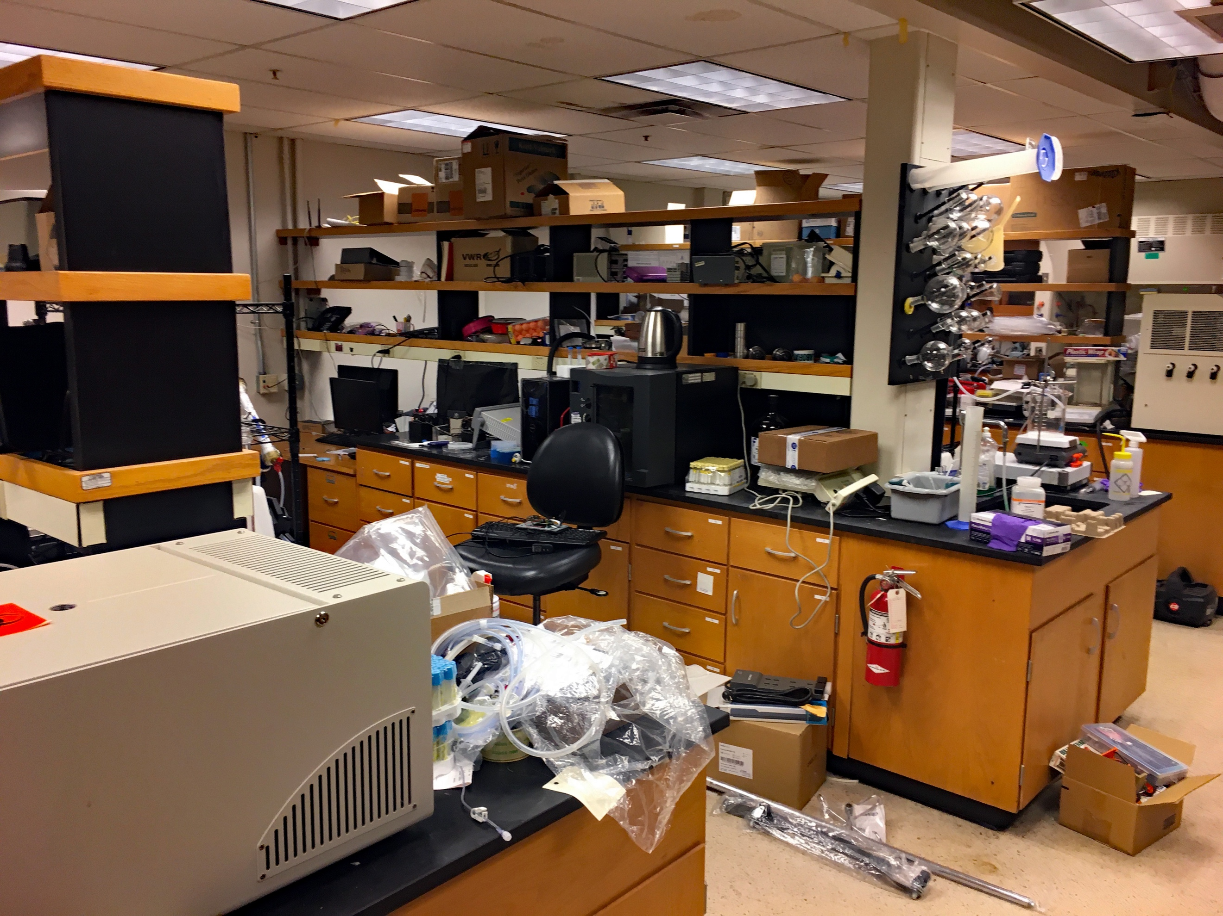

- Baer’s office was in a hallway behind 039 – although Baer and Richard Ladner (Ladner was hired as a new Berkeley graduate in 1971; he retired in 2017) subsequently were moved to a now-demolished wooden house south of Roberts.
  - Baer, too, is the author of an infamous letter – a 1970 complaint to the Dean of the Graduate School in which he described his office as “a passageway between two doors, without windows, with a transparent pipe flushing water in front of my desk” (http://lazowska.cs.washington.edu/history/baer.jpg).
- Graduate students were housed in three locations: the now-demolished wooden house south of Roberts, the “Pit” in the basement of Roberts, and the “Yellow Sub” – a “temporary” structure that is still in use 50 years later, most recently housing the general contractor’s administrative offices during the construction of the Bill & Melinda Gates Center for Computer Science & Engineering. This structure is now referred to as “Roberts Annex” for no discernable reason (not to be confused with the “Roberts Hall Annex” noted above).

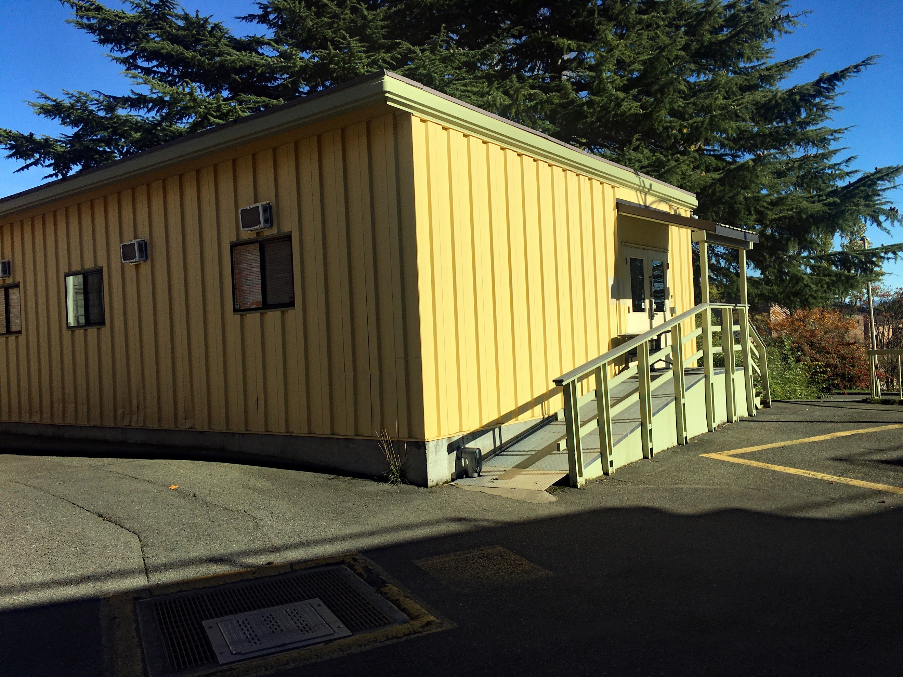

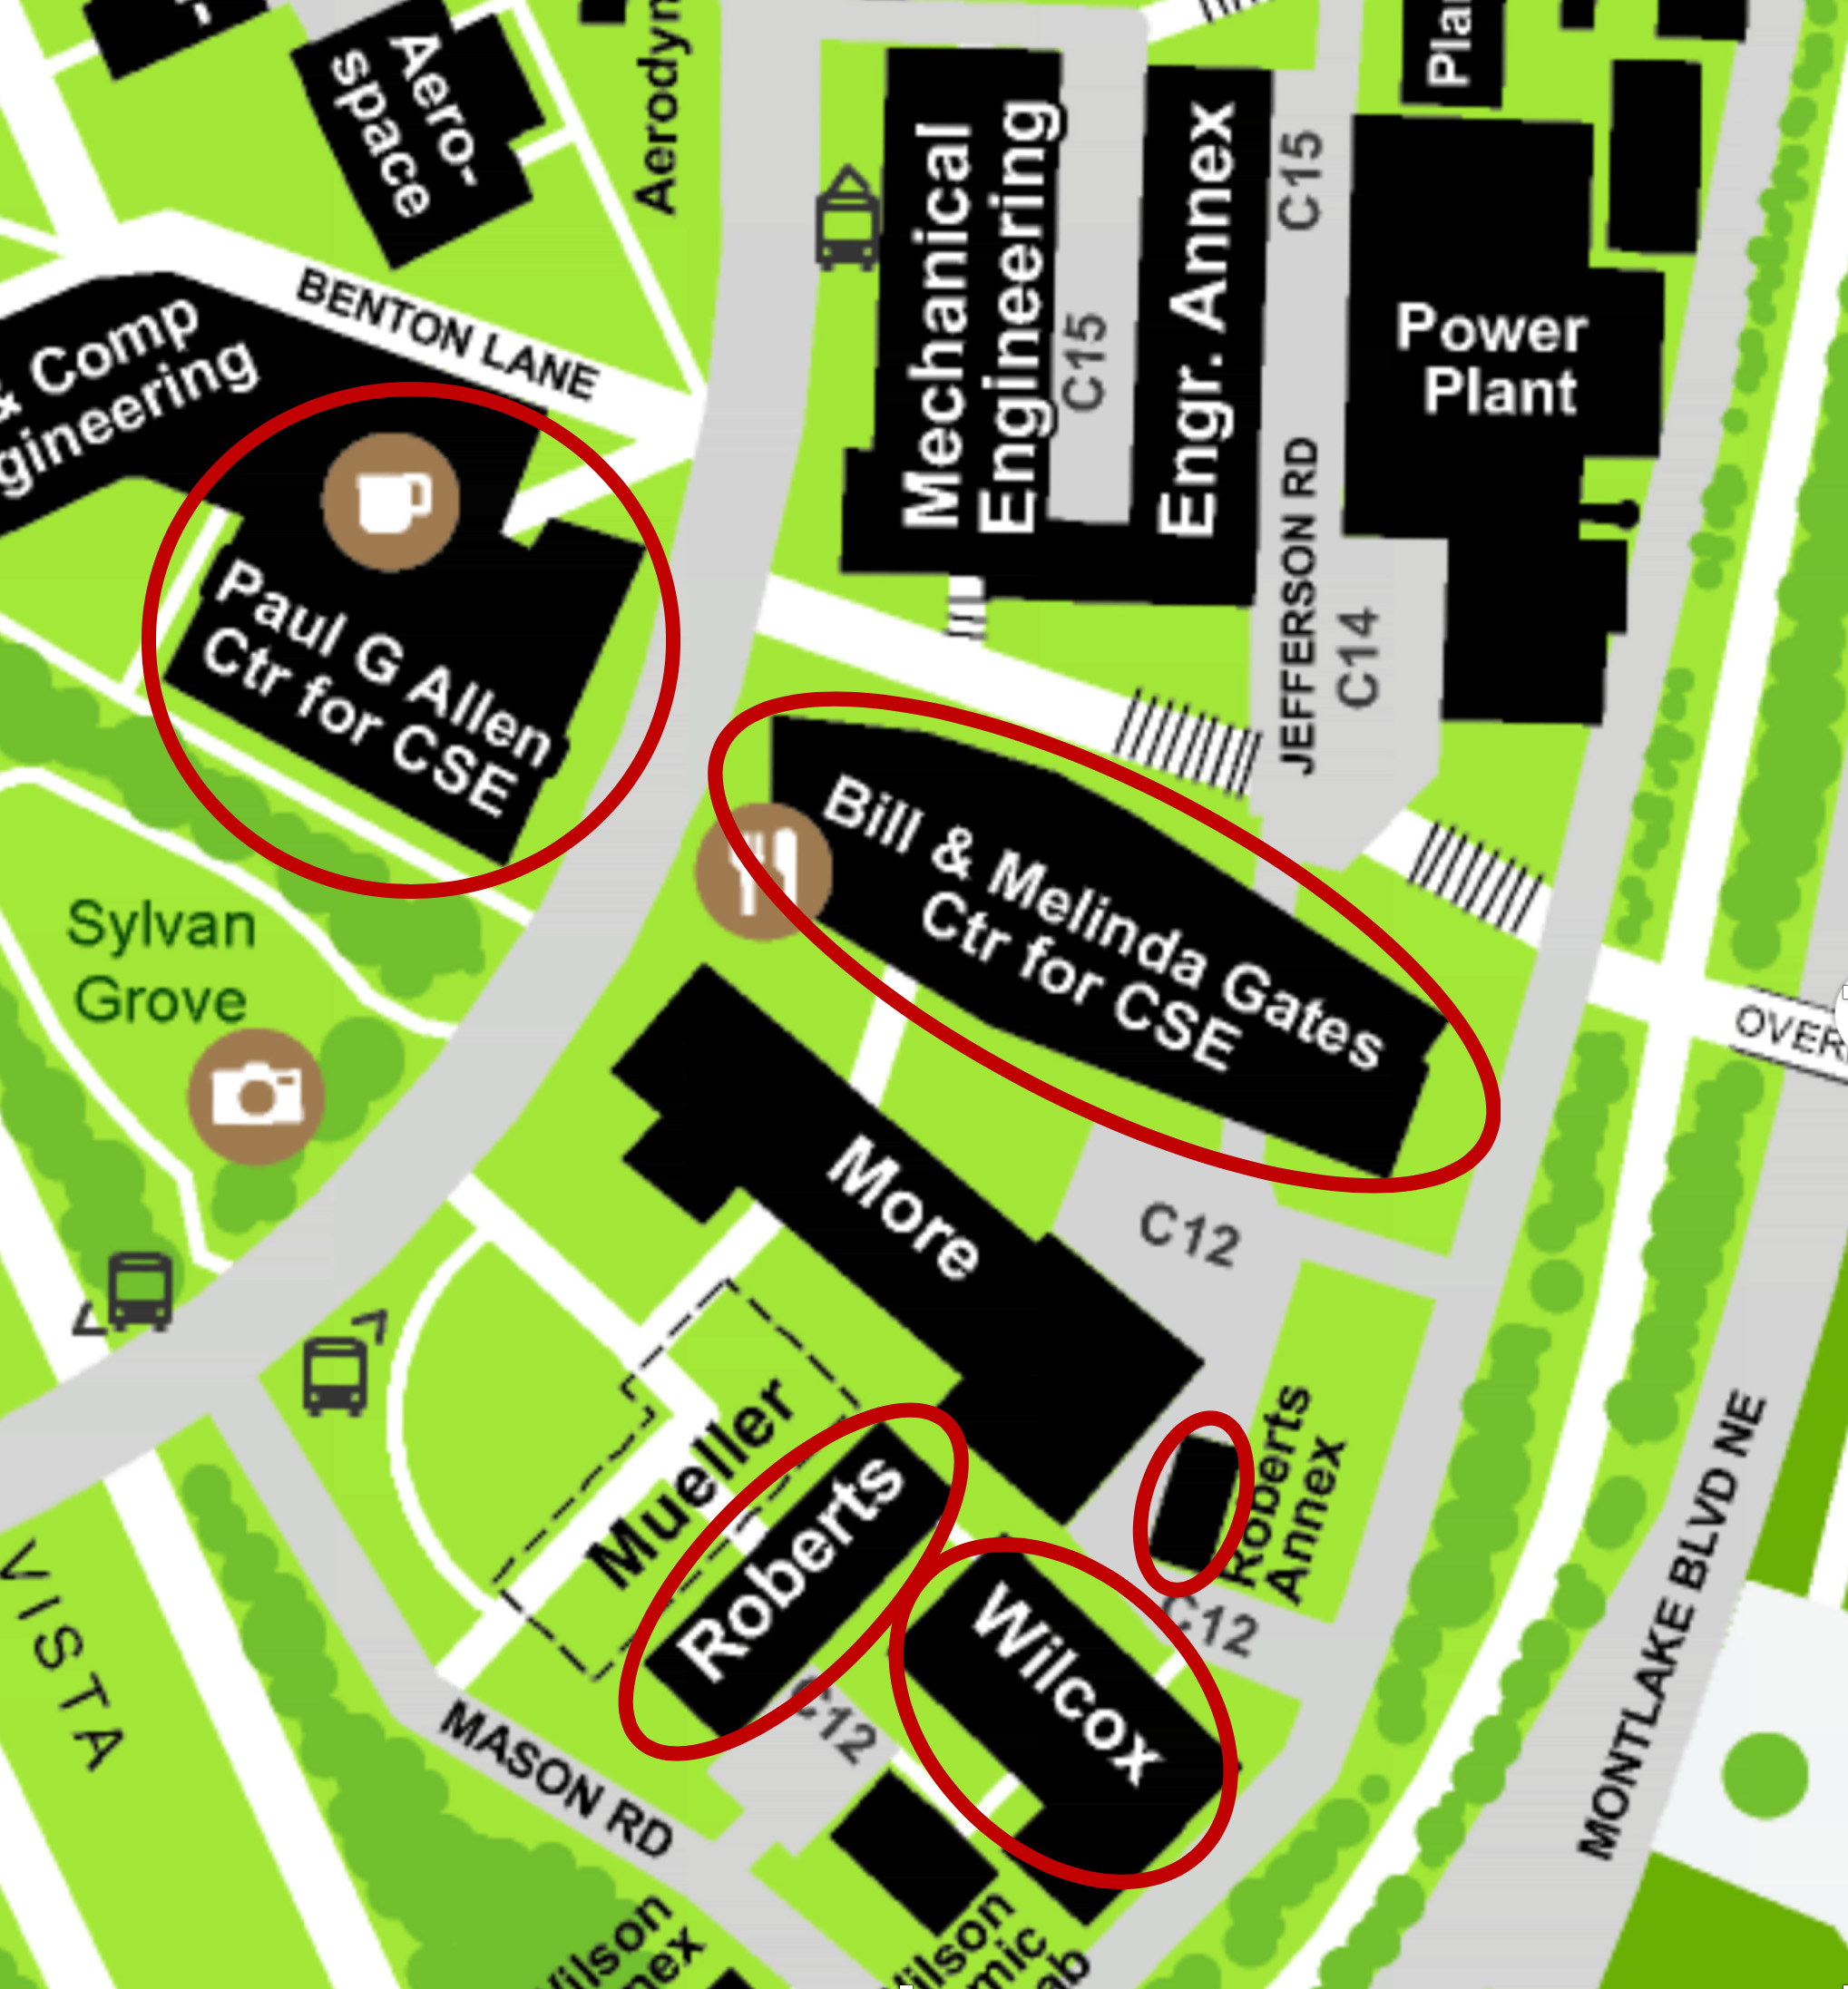

Bill Gates and Paul Allen used other computers on campus, and also at Computer Center Corporation (C^3), a timesharing startup that was formed mostly by former UW students and employees and that boasted a then-very-advanced DEC PDP-10. C^3 was located west of UW on Roosevelt Ave., at a site now occupied by Augusta Apartments, developed by Paul Allen’s Vulcan real estate operation (https://augustaseattle.com/our-story/).

Bill and Paul accessed these computers on-site, and also in some cases remotely using an ASR-33 Teletype terminal acquired by the Lakeside Mothers Club – site of several famous photographs of the high schoolers.

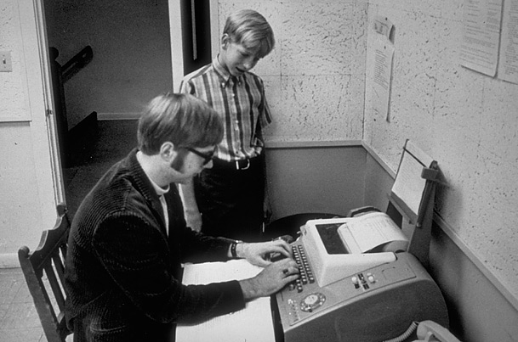

The Computer Science Group became the Department of Computer Science in 1974, and enrolled its first Bachelors students and moved to Sieg Hall in 1975. It became the Department of Computer Science & Engineering in 1989, moved to the Paul G. Allen Center of Computer Science & Engineering in 2003, became the Paul G. Allen School of Computer Science & Engineering in 2017, and added the Bill & Melinda Gates Center for Computer Science & Engineering in 2019.

